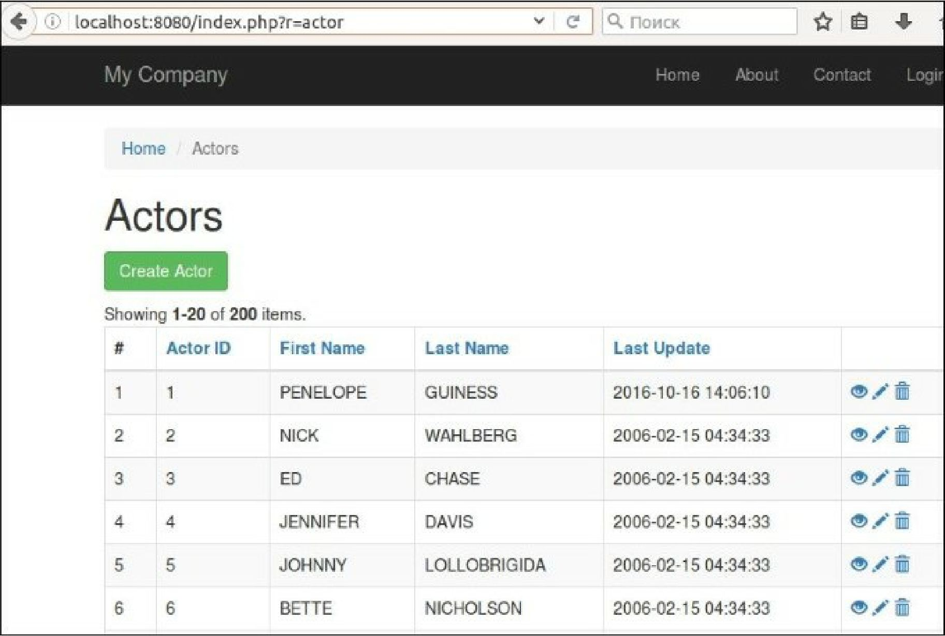

How it works...

If you check your project structure you will see autogenerated code: